# Travel With Me

## ***Goal***

We need to create a travel website that will have tour packages for different destinations.

The user will come to the website where he can select package as per his preference of destination and price and do the booking.

## ***Design Flow***

**Admin Panel**

* A country page to create, delete, update country
* A city page to create, delete, update country
* A package page to create, update and delete a package
* Listing page of the booking made by the user (Admin can make modification as well)
* Roles Page
* Users page to manage any create, update and delete
* Tag page to add tags to the package (Adventure, Beach etc)
* Category Page to add categories to the package (summer, weekend gateway etc)

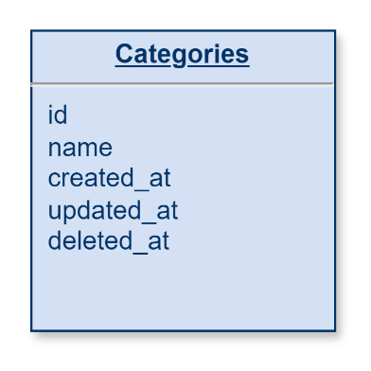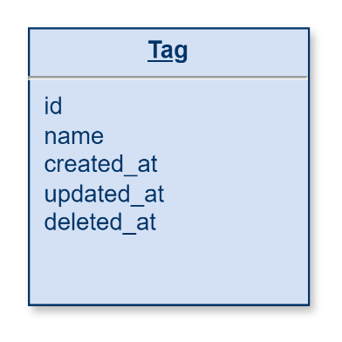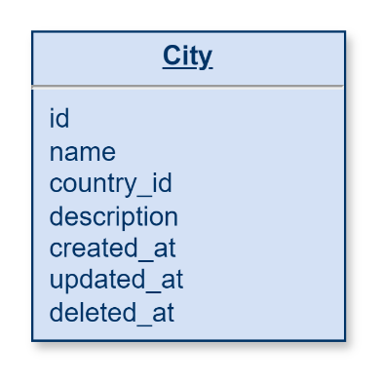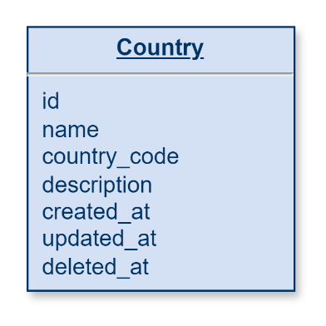**Database Design**

